Port Neches Little League 2024 ASAP Safety Plan League ID #3433209


Approved by Board of Directors:
Authorized League Signature:
Trey Gaspard, League President

Port Neches Little League Page 1 of 15

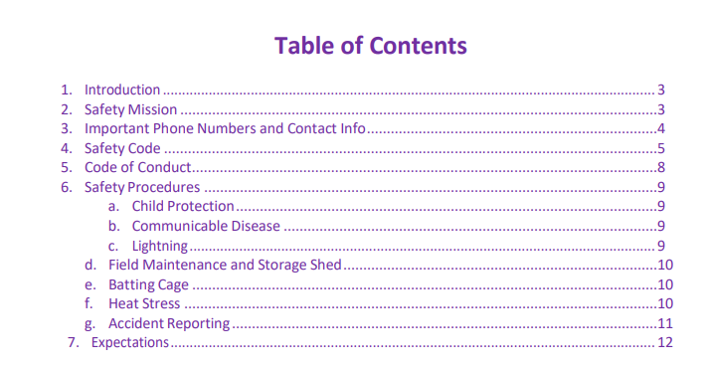

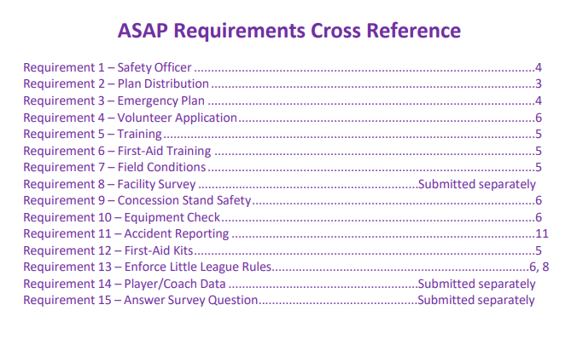

Port Neches Little League Page 2 of 15

1. Introduction
ASAP - What is it? In 1995, ASAP (A Safety Awareness Program) was introduced with the goal of re-emphasizing the position of Safety Officer “to create awareness, through education and information, of the opportunities to provide a safer environment for kids and all participants of Little League Baseball”. This manual is offered as a tool to place some important information at manager’s and coach’s fingertips.
Used in conjunction with the Little League Rule Book, Local Option Rules, the Play it Safe book, Protecting Young Pitchers Arms guide, and training for managers, coaches and other volunteers, this manual is part of the overall safety plan for our league.
Please read through this manual thoroughly and share it with your team. Safety is both an individual and team effort. If there are any questions, contact the Port Neches Little League Safety Officer - SEE list of IMPORTANT NUMBERS for contact information on the next page.
DISTRIBUTION:
This manual is provided to:
⮚ Each Team Manager
⮚ All Board Members
⮚ District #32 Safety Officer
⮚ Posting on website at www.pnlittleleague.com.

A copy is also available at the concession stand and/or league boardroom.

2. Safety Mission
Port Neches Little League strives to provide a fun and safe environment for the enjoyment of the game of baseball. For our players, parents, volunteers, and spectators, Port Neches Little League will pursue well maintained facilities and safety conscious coaches and volunteers.

Port Neches Little League Page 3 of 15
3. Important Numbers and Contact Info

Police / Fire / EMS | 911
Police | (409) 722-1424 (NON-EMERGENCY)
PNLL Safety Officer – Mark Lawson* | (409) 543-5511
* Contact Mark Lawson to track/report injuries.

2024 Board of Directors
Officers
President | Trey Gaspard | portnecheslittleleague@gmail.com | (409) 748-9452
Vice President | Chris Marioneaux | portnecheslittleleague@gmail.com | (409) 466-3243
Secretary | Leah Harrington | portnecheslittleleague@gmail.com | (409) 289-2497
Treasurer | Derek Rhoades | portnecheslittleleague@gmail.com | (409) 749-9733
League Information Officer | Jared Abshire | portnecheslittleleague@gmail.com | (409) 720-7412
League Safety Officer | Mark Lawson | portnecheslittleleague@gmail.com | (409) 543-5511
Directors
Concession Manager | Robert Harrington | portnecheslittleleague@gmail.com | (409) 718-0883
Marketing Director | Bryson Seaux | portnecheslittleleague@gmail.com | (409) 718-0691
Registration | Jared Abshire | portnecheslittleleague@gmail.com | (409) 720-7412
Fundraising | Hillary Erwin | portnecheslittleleague@gmail.com | (409) 225-0750
Sponsorships | Cara McNeill | portnecheslittleleague@gmail.com | (409) 548-1978
Uniform & Team Mom Coordinator | Kathryn French | portnecheslittleleague@gmail.com | (409) 719-7675
Field Maintenance Coordinator | Ben Parks | portnecheslittleleague@gmail.com | (409) 719-2615
Equipment Manager | Mark Lawson | portnecheslittleleague@gmail.com | (409) 543-5511
Umpire in Chief | Jordan McNeill | portnecheslittleleague@gmail.com | (409) 790-4191
Coaching Coordinator | Josh Gray | portnecheslittleleague@gmail.com | (409) 670-2188
Players Agent (Major)  Players Agent (Minor) | Jeff Fox  Joe Fowler | portnecheslittleleague@gmail.com | (409) 550-9075  (409) 790-9676

Port Neches Little League Page 4 of 15
4. Safety Code

• Responsibility for safety procedures should be that of an adult member of the League.
• Arrangements should be made in advance of all games and practices for emergency medical services. Emergency phone numbers will be posted in the concession stand.
• Managers and coaches must have training in first aid (incl CPR/AED) and baseball fundamentals.
• Baseball Fundamental Training: Before March 6th
• Mandatory Coach Safety Training: Before March 6th
• First-aid supplies/kits will be available to each team and are located at the concession stand.
• No games or practices should be held when weather or field conditions are not good, particularly when lighting is possible.
• Play area should be inspected by coaches frequently for holes, damage, rocks, glass, etc.
• If issues are noted on a playing field, please inform the PNLL Field Maintenance Director (contact info provided above).
• All team equipment should be stored within the team dugout, or behind screens, and not within the area defined by the umpires as “in play”.
• Only players, managers, coaches, and umpires are permitted on the playing field or in the dugout during games and practice sessions.
• Responsibility for keeping bats and loose equipment off the field of play should be that of a player assigned for this purpose, or the team’s manager and coaches.
• Procedure should be established for retrieving foul balls batted out of the playing area.
• During practice and games, all players should be alert and watch the batter each pitch.
• During warm-up drills players should be spaced so that no one is endangered by wild throws or missed catches.
• All pre-game warm-ups should be performed within the confines of the playing field, and not within areas that are frequented by, and thus endanger spectators (i.e., playing catch, pepper, swinging bats, etc.)
• Equipment should be inspected regularly for the condition of the equipment, as well as for proper fit. Broken equipment must be replaced.
• Batters must wear Little League approved helmets and only use approved USA Approved Bats during batting practice and games. NO EXCEPTIONS.
• Catchers must wear catcher’s helmet, mask, throat guard, long model chest protector, shin guards and protective cup with athletic supporter always (males) for all practices and games. NO EXCEPTIONS.

Port Neches Little League Page 5 of 15
• The Catcher must wear a catcher's helmet and mask with a throat guard in warming up pitchers. This applies between innings and in the bullpen during a game and during practices.
• Managers and Coaches may not warm up pitchers before or during a game (Rule 3.09).
• Managers should encourage all male players to wear protective cups and supporters for practices and games.
• Except when a runner is returning to a base, headfirst slides are not permitted.
• During sliding practice, bases should not be strapped down or anchored.
• During games, breakaway “safety bases” shall be used, if available.
• At no time should “horse play” be permitted on the playing field.
• Coaches/umpires should walk fields before use to ensure fields are safe and playable. Any unsafe conditions should be corrected or, if immediately uncorrectable, reported to the League Safety Officer.
• Parents of players who wear glasses should be encouraged to provide “safety glasses”.
• Players must not wear watches, rings, pins or metallic items during games and practices.
• On-deck batters are not permitted.
• Concession stand staff will receive training in proper food handling, and concession stand safety. Safety procedures (See Appendix 2) will be posted.
• All volunteers must fill out a Little League Volunteer Application form and consent to a mandatory background check.
• Our League is utilizing JDP Background Screening. Instead of completing the application form, please log into the league website and provide your full name and email address in the volunteer application. A link will then be provided for you to enter your information directly into the JDP System for processing.
• Anyone that refuses a background check is ineligible to be a volunteer.
• The safety officer will perform an annual safety inspection of the Port Neches Little League facilities. Deficiencies shall be communicated to the league president and resolved appropriately. The Annual Little League Facility Survey will be submitted to Little League International with the submission of this annual safety plan and the safety plan registration form.
• League registration data and/or roster data and coach/manager data will be uploaded to the Little League Data Center upon closing of registration.

Port Neches Little League Page 6 of 15
Some Important Do’s and Don’ts
Do ...
• Reassure and aid children who are injured, frightened, or lost.
• Provide, or assist in obtaining, medical attention for those who require it. • Know your limitations.
• Carry your first-aid kit to all games and practices.
• Keep your “Prevention and Emergency Management of Little League Baseball and Softball Injuries” booklet with your first-aid kit.
• Assist those who require medical attention - and when administering aid, remember to... .... LOOK for signs of injury (blood, black-and-blue deformity of joint, swelling, etc.).
..... LISTEN to the injured describe what happened and what hurts if conscious. Before questioning, you may have to calm and soothe an excited child. If injured person is unconscious, call 911 immediately and do not move the injured person.
..... FEEL gently and carefully the injured area for signs of swelling.
• Make arrangements to have a cellular phone available when your game or practice is at a facility that does not have any public phones.
Don’t ...
• Administer any medications.
• Provide any food or beverages (other than water).
• Hesitate in giving aid when needed.
• Be afraid to ask for help if you’re not sure of the proper procedures (i.e., CPR, etc.). • Transport injured individuals except in extreme emergencies.
• Leave an unattended child at a practice or game.
• Hesitate to report any present or potential safety hazard to the Safety Officer, immediately.
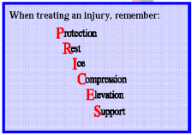

Port Neches Little League Page 7 of 15

5. Code of Conduct

• Speed Limit 5 mph in parking lots while attending any Little League function.
• Watch for small children moving in between and around parked cars.
• No alcohol allowed in any parking lot, field, or common areas within a Port Neches Little League complex.
• No Playing in parking lots at any time.
• No Playing on and around lawn equipment.
• Use cross- walks when crossing roadways. Always be alert for traffic.
• No profanity.
• No swinging bats or throwing baseballs at any time outside the designated areas at the Port Neches Little League complex. Players not currently batting in a properly designated areas should not have bats in-hand; bats should be put away or laying on the ground until it is such player’s time to bat.
• No throwing balls against dugouts or against fences and backstops.
• No throwing rocks.
• No horseplay in walkways at any time.
• No climbing fences.
• Only a player on the field and at bat, may swing a bat (Age 4 - 12).
• Observe all posted signs. Players and spectators should always be alert for foul balls and errant throws.
• During a game, players must always remain in the dugout area in an orderly fashion.
• After each game, each team must clean up trash in dugout.
• All gates to the field must always remain closed. After players have entered or left the playing field, gates should be closed and secured.
• No children under the age of 15 are to be permitted in the Concession Stand unless granted permission by the adult in charge/Concessions Director.
Failure to comply with the above may result in expulsion from the Port Neches Little League field or complex.

Port Neches Little League Page 8 of 15
6. Safety Procedures

CHILD PROTECTION PROCEDURE
- All volunteers having repeated access to the children of the league must complete a Little League Volunteer Application form and will be checked for sexual offenses against children. This includes all board members, managers, coaches, and team parents.

COMMUNICABLE DISEASE PROCEDURES
1. Bleeding must be stopped, the open wound covered, and the uniform changed if there is blood on it before the athlete may continue.
2. Routinely use gloves to prevent mucous membrane exposure when contact with blood or other body fluids is anticipated (provided in first-aid kit).
3. Immediately wash hands and other skin surface if contaminated with blood. 4. Clean all blood contaminated surfaces and equipment.
5. Managers, coaches, and volunteers with open wounds should refrain from all direct contact until the condition is resolved.
6. Follow accepted guidelines in the immediate control of bleeding and disposal when handling bloody dressings, mouth guards and other articles containing body fluids.
LIGHTNING PROCEDURES
At Practices....
1. Be aware of weather reports before heading to your practice field.
2. At the first sign of approaching weather or sound of thunder, stop practice immediately and get everyone into cars or inside a walled building. DO NOT congregate under trees or near metal fences/backstops.
3. DO NOT wait for the first sight of lightning. The first one could be the one that hits you! 4. Do not resume practice until the weather has safely passed.
Managers are responsible for player safety at practices...DO NOT RISK SAFETY!
At Games....
1. The league’s Lightning Detector will be kept in the concession stand.
2. When approaching lightning is detected to be within the unsafe distance zone from the field, the person monitoring the lightning detector (Board Member on Duty), the Board Member on Duty will then sound an air horn (3 Long Bursts, Pause, 3 Long Bursts) to notify the other fields that lightning is approaching.
3. The home plate umpires on all fields will immediately stop play and clear the fields. 4. All managers, coaches, and players will immediately move all players to safe surroundings...either inside a solid building or inside cars.
5. No one is to remain outside or in the dugouts.
7. When the lightning detector indicates a safe condition, the Board Member on Duty will sound the air horn (2 Quick Bursts, Pause, 1 Long Bursts) for the games to be resumed.

Port Neches Little League Page 9 of 15

FIELD MAINTENANCE and STORAGE SHED PROCEDURES
1. All individuals using the equipment sheds (i.e., Managers, coaches, Umpires, etc.) are aware of their responsibilities for the orderly and safe storage of rakes, shovels, bases, etc.
2. Before you use any machinery located in the shed (i.e., lawn mowers, weed whackers, lights, scoreboards, public address systems, etc.) please locate and read the written operating procedures for that equipment. Also remember that you must be approved as an authorized user by the Field Maintenance Directors.
3. All chemicals or organic materials stored in Port Neches Little League sheds shall be properly marked and labeled as to its contents.
4. All chemicals or organic materials (i.e., lime, fertilizer, etc.) stored within these equipment sheds will be separated from the areas used to store machinery and gardening equipment (i.e., rakes, shovels, etc.) to minimize the risk of puncturing storage containers.
5. Any witnessed “loose” chemicals or organic materials within these sheds should be cleaned up and disposed of as soon as possible to prevent accidental poisoning.
6. No one under the age of 18 is allowed to operate any power or electrical equipment, or handle any chemicals.
7. When using equipment such as weed whackers, proper eye protection should be used.
BATTING CAGE PROCEDURES
1. A maximum of two children are allowed in the batting cage at a time... a batter with proper batting helmet, and catcher in full gear, if desired.
2. The use of a pitching machine must be set up, put away and operated by an adult only.
3. No children can stay behind the “L” screen with the adult feeding the machine or throwing.
4. No players should be swinging a bat outside the cages.
5. Throwing balls in the area around the cages is not allowed.
HEAT STRESS AWARENESS
Make sure to allow practice breaks that provide fluid consumption and shade from the sun. Be aware of the following
Signs and Symptoms:
• Mild – sweating, irritability, heat cramps
• Moderate (Heat Exhaustion) – excessive sweating, weakness, dizziness, cold skin, pale/clammy
• Severe (Heat Stroke) – lack of sweat (hot dry skin), headache, nausea, confused/dizzy, rapid pulse
Remember to get help immediately if moderate or severe cases are suspected.
Port Neches Little League Page 10 of 15
ACCIDENT REPORTING PROCEDURE
What to report - An incident that causes any player, manager, coach, umpire, or volunteer to receive medical treatment and/or first aid must be reported to the Safety Officer, appropriate Player Agent, and league President. This includes even passive treatments such as the evaluation and diagnosis of the extent of the injury or periods of rest.
When to report - All such incidents described above must be reported to the Safety Officer, appropriate Player Agent, and the league President within 24 hours of the incident. (See page 4 for contact info).
How to make the report - Reporting incidents can come in a variety of forms. It is recommended to use Appendix 1, Incident/Injury Report. Most typically, they are telephone conversations. At a minimum, the following information must be provided:
• The name and phone number of the individual involved.
• The date, time, and location of the incident.
• As detailed a description of the incident as possible.
• The preliminary estimation of the extent of any injuries.
• The name and phone number of the person reporting the incident.
Safety Officer’s Responsibilities - Within 48 hours of receiving the incident report, the Safety Officer will contact the injured party or the party’s parents and (1) verify the information received; (2) obtain any other information deemed necessary; (3) check on the status of the injured party; and (4) in the event that the injured party required other medical treatment (i.e., Emergency Room visit, doctor’s visit, etc.) will advise the parent or guardian of the Port Neches Little League’s insurance coverage and the provisions for submitting any claims.
If the extent of the injuries are more than minor in nature, the Safety Officer shall periodically call the injured party to (1) check on the status of any injuries, and (2) to check if any other assistance is necessary in areas such as submission of insurance forms, etc. until such time as the incident is considered “closed” (i.e., no further claims are expected and/or the individual is participating in the league.
If any league office reporting is required, the Safety Officer shall be responsible to ensure the process is completed in a timely manner.

Port Neches Little League Page 11 of 15
7. Expectations
WHAT, AS A MANAGER, DO I EXPECT FROM MY PLAYERS?
• To be on time for all practices and games.
• To always do their best whether in the field or on the bench.
• To be cooperative at all times and share team duties.
• To respect not only others, but themselves as well.
• To be positive with teammates at all times.
• To try not to become upset at their own mistakes or those of others ... we will all make our share this year and we must support one another.
• To understand that winning is only important if you can accept losing, as both are important parts of any sport.
WHAT CAN YOU AND YOUR CHILD EXPECT FROM ME?
• To be on time for all practices and games.
• To be as fair as possible in giving playing time to all players.
• To do my best to teach the fundamentals of the game.
• To be positive and respect each child as an individual.
• To set reasonable expectations for each child and for the season.
• To teach the players the value of winning and losing.
• To be open to ideas, suggestions or help.
• To never holler at any member of my team, the opposing team or umpires. Any confrontation will be handled in a respectful, quiet and individual manner.

WHAT DO I EXPECT FROM YOU AS PARENTS AND FAMILY?
• To come out and enjoy the game. Cheer to make all players feel important.
• To allow me to coach and run the team.
• To try not to question my leadership. All players will make mistakes and so will I.
• Do not holler at me, the players or the umpires. We are all responsible for setting examples for our children. We must be the role models in society today. If we eliminate negative comments, the children will have an opportunity to play without any unnecessary pressures and will learn the value of sportsmanship.
• If you wish to question my strategies or leadership, please do not do so in front of the players or fans. My phone number will be available for you to call at any time if you have a concern. It will also be available if you wish to offer your services at practice. A helping hand is always welcome.
• Finally, don’t expect the majority of children playing Little League baseball to have strong skills. We hear all our lives that we learn from our mistakes. Let’s allow them to make their mistakes, but always be there with positive support to lift their spirits!
• Little League Parent program: https://www.littleleague.org/parents/

Port Neches Little League Page 12 of 15
Appendix 1
Incident/Injury Tracking
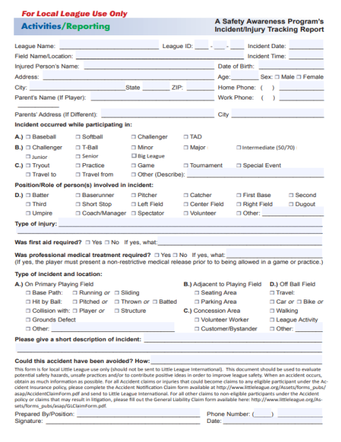

Port Neches Little League Page 13 of 15
Appendix 2
Concession Safety (Click Hyperlink for PDF)
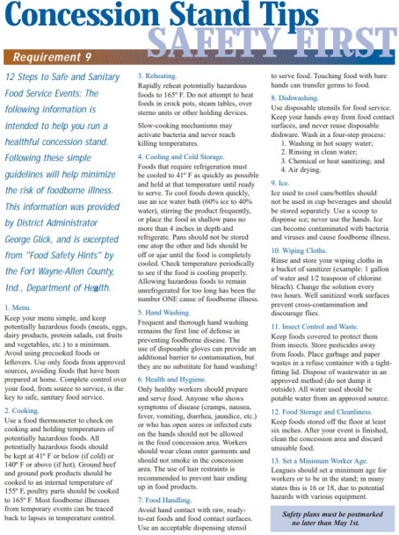

Port Neches Little League Page 14 of 15
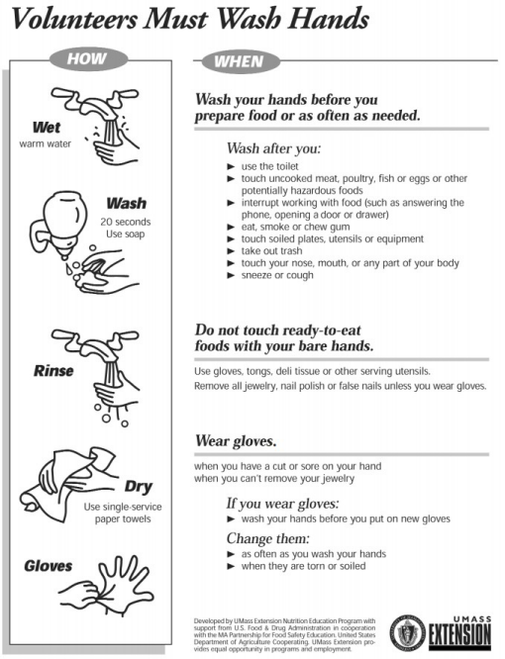

Port Neches Little League Page 15 of 15

